Landen Barber
12/7/25
Draft Report

Contents
Abstract 3
Chapter 1: Introduction 4
Chapter 2: Background 5
Comparisons with Existing Approaches 5
Twiddler 5
Azeron 6
3d Modeled Addons 7
Xbox Adaptive Controller 7
Chapter 3: Design Details 9
Requirements 9
Critical Requirements 9
Design and User Interface 10
Functionalities and Operational Conditions 11
Comparison Matrices / Parts List 15
Matrix 1 - Microcontrollers 15
Matrix 2 - Joysticks 16
Matrix 3 - BLEs 17
Matrix 4 - Haptic motors 17
Matrix 5 - Charger Circuits 18
System Block Diagrams 19
Top Level Block Diagram 19
Hardware Block Diagram 20
Software Block Diagram 21
Functional Block Diagram 22
Cost Estimation 23
Components Cost 23
Production Cost 23
NRE Costs 24
Operational Cost 24
Total Cost 24
Chapter 4: Testing & Evaluation 25
Chapter 5: Conclusion & Future Work 26
Timeline 26
Fall Term Timeline 26
Winter Term Timeline 26
Spring Term Timeline 27
References 28
Appendix 29
Appendix A: Bill of Materials 29

Abstract
This project presents the design and development of a one-handed accessibility controller intended for users with limited mobility or for that accessibility focused. This report specifically outlines the current system architecture and design decisions as well as chosen hardware and chosen parts as of Fall 2025. You can also find a list of requirements and details needed for completion by Spring 2026.

Chapter 1: Introduction
For my senior project I will design a one-handed accessibility controller aimed at expanding on the limited number of input options that a one-handed controller may have. What makes this controller special will be the highly customizable nature and vertical form factor that other controller producing companies leave nearly untouched. It will also be compatible with various systems without the need for installed software. It will come packed with an overlay to change settings and a digital keyboard to be able to easily type using the device.
There are a few central challenges to making this type of controller and many things to consider. Alongside the normal challenges like battery life, size constraints, and connectivity/support for different applications, a one-handed controller is unique in that the physical number of inputs that can be implemented is cut short. To combat this, the controller will feature gyro and chorded input to supplement the number of inputs possible and will have a swappable backplate to add more functionality and customizability to suit the user’s preference. Overall, the goal of this project is to have an intuitive one-handed controller that is easily adjustable to a variety of hand sizes and mobility limitations and aims to empower users with limited mobility to provide a device capable of connecting them to their machine.
To improve the tweakability of the device, many of the IO will be highly customizable. For starters, each function will be able to be turned on and off, and most of the inputs could be remapped to any function. Specific IO will also have their own settings to tune and customize to best suit the user. The two joysticks, for example, are an input option that could be changed completely based on different settings. Having the option to lock certain axes, adjust gradual acceleration, or having it work more like a button are all things that could be done to allow the user to customize it to their liking.
In order to take full advantage of this customizability the controller will come with a software overlay that could be brought up on any computer to change settings, rebind inputs, or disable components. It will provide a centralized interface that any user can use to customize these features and select profiles. Using this overlay, the controller will also be able to track the users’ inputs to be able to do background calibration to tune the devices parameters to better suit the user. Using the input history and a usage heatmap, the overlay can identify patterns such as frequently used inputs, common motion ranges, and areas of unintentional activation and use them to suggest or apply adjustments to parameters such as dead zones, sensitivity curves, axis limits, and chord timing. Therefore, allowing the controller to adapt over time to the user’s physical capabilities and interaction style.
Since this controller focuses on accessibility and customization, the audience for this kind of device are those with limited mobility or accessibility-focused users who are looking for a comfortable handheld one-handed device to implement with their devices. But at the current state of this project, these requirements and use cases best fit the customizability side of this project, and though this customizability can be seen as something to support accessibility, does little for the accessibility side. Something that does directly reflect the accessible use of this controller is the use of gyro-based input that allow users to translate subtle wrist or hand movements into precise control, reducing the need for additional physical buttons while accommodating users with limited dexterity or strength.
To achieve these goals, the controller will utilize various parts. Central to this project is the Nucleo-WB15CC board with its embedded BLE functionality, as well as components like the USB-C breakout board to split data and power, the PowerBoost 1000C to handle a battery connection to supplement the desired functionality of having a wired or Bluetooth connection.
Throughout this document I will start by looking at the background of some other popular options for accessibility controllers, as well as one that is very similar to my own, and explain what makes mine different. I will then describe my timeline as well as the challenges and ways to mitigate and handle them. Finally, I will talk about the requirements that the final product should include.

Chapter 2: Background
Traditionally, controllers are designed for those with full use of both hands. While the standard controller can work for the majority of people, it can provide a barrier to those with disabilities or limited mobility. As Accessibility is becoming a more prominent aspect within technological and gaming spheres, there is a growing need for inclusive and specialized hardware. But, despite efforts by various companies, there remains a limited selection of intuitive, one-handed controllers that are compatible with many applications and games.
There are several previous technologies that have attempted to solve this problem before, but each comes with their own tradeoffs. One approach is the Azeron gaming keypad, which effectively acts like a mouse with finger actuated input. The mouse input on the controller allows for more precise aiming and works well with a computer system, it also comes with extensive customization options. Another approach that is very similar is the Twiddler. The twiddler is a one-handed keyboard that includes chorded input. The biggest problem with this is that it is meant for typing and is primarily meant for use by a tablet or other mobile device via Bluetooth. Both of these products demonstrate different aspects that I would like to bring together in order to create a more suited device toward gaming. There have also been attempts of at home solutions like 3d printed additions to your base controllers that move many of the buttons to one side, though these solutions are usually heavier and more clunky.

Comparisons with Existing Approaches

Twiddler
The twiddler is a one-handed chorded keyboard device made by a company called Tek Gear, Inc. While both my project and the Twiddler use chorded input within a one-handed form factor, the purpose and audience for each one differ fundamentally. Twiddler controllers are optimized for entering text quickly and efficiently and are not aimed toward those with disabilities. To lay out all of the differences, Twiddler keyboards have 12 keys, some are remappable while some are not, an optical mouse touchpad, Bluetooth capable, but is not ambidextrous, has no haptic feedback, and is primarily meant for a niche text-entry focused audience. The twiddler is sold for 229 dollars retail and excels at being highly portable and highly programmable. Some weaknesses of this design though it that it has a steep learning curve and is not optimized for general use or accessibility.
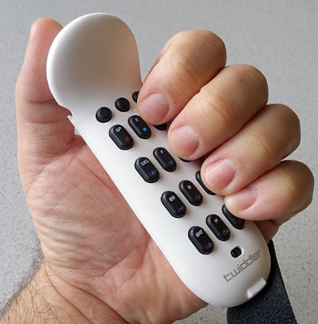

Azeron
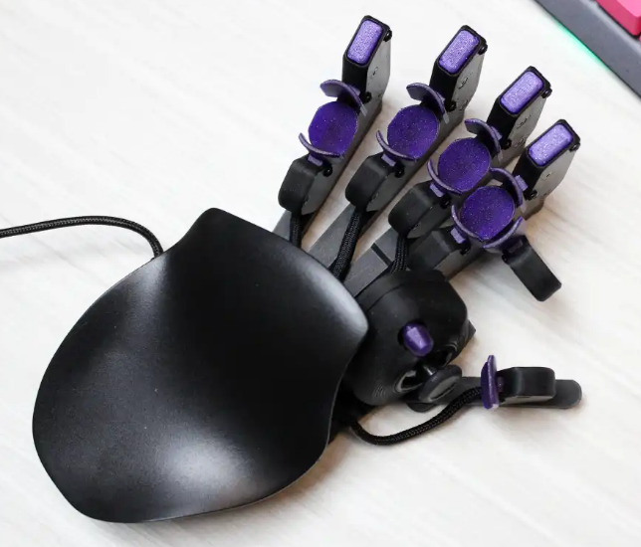
Azeron controllers are one-handed programmable gaming keypads designed primarily for PC gamers who want a smoother gaming experience with easily accessed inputs meant for use by those with one hand. This controller has an analog thumb stick, 26 programmable buttons, and an optical mouse sensor. It also has finger actuators to allow another degree of freedom. The strength of this controller is that it excels at general PC use and gaming, as well as being highly customizable to suit a specific purpose. A big downside to this controller though is that since it is more related to keyboards and mice, they are meant to be used mainly for PC’s and are not compatible with many other systems. Another downside of this device is its cost as it sells for around 220$ most likely due to its many moving pieces and actuators.

3d Modeled Addons
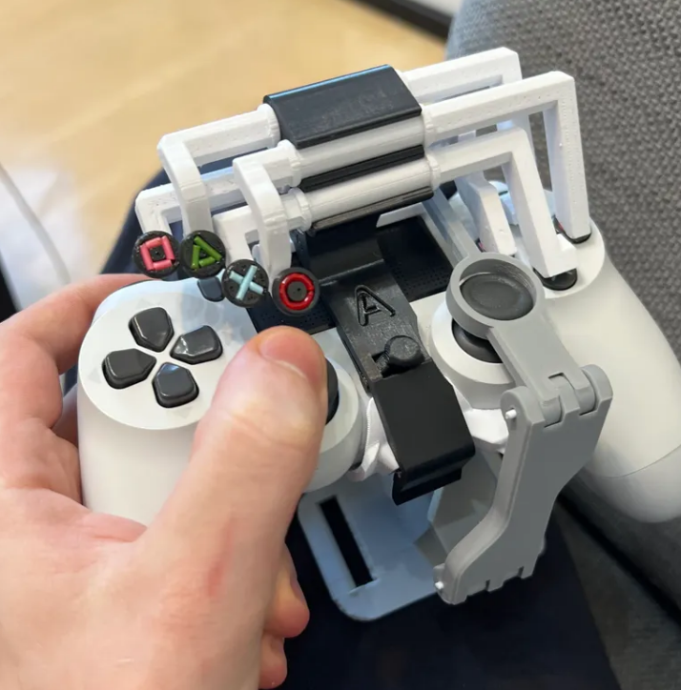
The simplest and cheapest approach to this need for a one-handed controller is one of the many designs of 3d printed models that could be attached to a normal gamepad controller. These are very low cost and build on the pre-built functionality and software that a normal gamepad has already. These are good options for those with access to a 3d printer, but even if you don’t have a 3d printer they are still easy to find online. Some problems with this design though is that it can be difficult to assemble, and makes the controller more clunky and only adds to the weight of a controller meant for 2 hands.

Xbox Adaptive Controller
Though not very related to my project, another popular choice for those with disabilities is the Xbox adaptive controller; this is a flat controller that has few buttons but has many inputs. Unlike other controllers, it functions as a brain that many other accessibility devices can be connected to and be used in conjunction with each other by providing an interface for people who are less tech savvy and need to set up multiple devices. This device is one of the strongest for being highly expandable and gives a lot of accessibility support. A big downside of this controller though is that it requires that you have other devices on hand in order to make full use of it, it is also quite big and is not very portable as it should be mounted to something like a desk or a wheelchair.
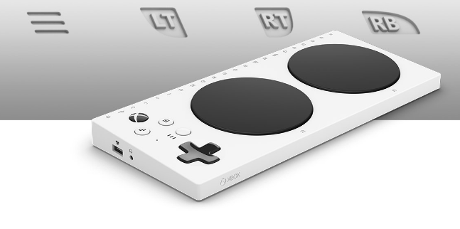

Chapter 3: Design Details

Requirements

Critical Requirements

1. The controller shall support full operation with one hand.
This is the core purpose of this project as the controller is meant for individuals who may not have full use of both hands. If the controller cannot be comfortable and intuitive when used with one hand of either orientation, then the device has failed its primary objective.
To validate this requirement, I will ask various classmates and friends to simulate using the device with one hand and having them complete tasks as to receive their feedback.

2. The controller shall be highly customizable.
This is important for expanding on the use cases of the controller and allow those he need slight adjustments to have easy access to how the controller works for them.
For validation, settings could be tested live to make sure that they are working on the fly and as intended.

3. The system shall include an overlay for configuration and troubleshooting.
An overlay like this is necessary to allow users to customize the functionality of the controller, including but not limited to key bind mapping, managing profiles, and changing settings. These things allow the controller to have critical flexibility for many use cases.
To validate this requirement, the overlay should be opened on multiple systems to test whether it has full functionality in changing settings on a variety of devices.

3a. The controller shall have an inbuilt digital keyboard.
To allow for better general use, a digital keyboard will be built into the system overlay so that you could easily type using the joysticks and buttons.

3b. The controller shall monitor input and subtly change settings and suggest changes based on input history.
To take further advantage of the onboard settings and adaptability, the controller will monitor the inputs of the user and suggest changes based on a usage heatmap, and input history.

4. The controller shall support various platforms including Windows, Xbox, and PlayStation.
The ultimate goal of this project is to be as versatile as possible without the use of third-party software. And to accomplish this, the controller will need to be natively compatible with various common systems in order to maximize usability and prevent it from being limited to a single ecosystem.
To verify this, the controller should be able to connect and communicate with a variety of systems and test its functionality as an input device.

Design and User Interface

5. The controller shall include a modular backplate for left- or right-handed use.
To support a wider range of users, the controller will be designed with this feature in mind to ensure the controller can comfortably fit a variety of hand sizes on either orientation. The backplate must be attached securely and align with internal components to allow both functionality and comfort.

5a. The controller shall have a symmetrical layout to accommodate left- or right-handed use.
In order to accommodate an ambidextrous design, buttons, triggers, and analog sticks will have to be designed in a symmetric fashion.

6. The controller shall include tactile markers to help distinguish similar-feeling buttons.
This is a feature that is small but can have a considerable difference for ease of use and would decrease the likelihood of making input errors.

7. The controller shall allow switching between different user-made profiles for different scenarios.
In order to support even more use cases, users will be able to create, save, and switch between different key profiles that may be used in different contexts.

7a. The controller automatically switches between profiles when switching contexts.
To make the controller more usable, the controller will automatically detect applications and switch to the appropriate profile rather than forcing the user to do it manually.

8. All physical buttons and combinations shall be remappable via the system overlay.
To allow the most amount of usability, users should be able to remap any physical button or joystick in order to adapt to individual needs and specific uses.

8a. Buttons shall have settings to change base functionality.
Buttons will have various settings to help get the desired functionality of the user, for example some settings would be Hold for rapid press, hold for toggle, adjust button bounce strength, and have the ability to adjust timings.

9. The controller should be able to have any of the io functionality disabled.
For better customization and comfort any of the io interfaces, haptics, gyro, or features can be disabled to allow fr less error in making inputs.

10. The controller shall support integrated chorded input.
As the controller will undoubtedly have limited physical buttons due to size constraints, this will allow for much more input versatility which is crucial for one handed support.

10a. The controller shall include a button to either toggle or enable chorded input when pressed.
This feature will allow the user to more easily use chorded input alongside standard input, maximizing the number of usable buttons. Choosing between toggle and hold would be done within the system overlay.

11. The controller shall have custom macro support.
To make more advanced sequences of button presses more usable, macros can be recorded and edited within the system overlay. These macros can be bound to different buttons or gestures for easy activation.

12. The controller shall support gestures using the on-board gyro and accelerometer.
To add another layer of input and accessibility, the movement of the controller should be considered and allow for gestures and movement to be a viable option of control over the system.

12a The controller shall allow the gyroscope to be used as a mouse.
The movement of the gyroscope and orientation of the controller could be used to move the mouse for general use. A button should be added to allow for orientation pausing to allow for readjustment and movement not related to mouse input.

12b The controller shall allow gestures to be mixed and matched in the settings.
Gestures will be supported with deep settings support to allow for some gestures while ignoring other. You should also be able to change the sensitivity, speed, and tremor/haptic filters.

Functionalities and Operational Conditions

13. The controller shall include a rechargeable battery enabling USB-C charging.
In order to support wireless functionality, a rechargeable battery will be essential for long term use and universal compatibility with USB-C cables for charging.

13a. The controller shall include a battery level indicator via LEDs.
A visual indicator of the battery level ensures that users will know when the device will need to be charged. This will additionally show when the device is on or off.

13b. The controller shall enter sleep mode after a time to save battery life.
To conserve battery life and health, the controller will automatically detect inactivity and enter a low power mode and wait for the user to come back. After further inactivity the controller will then shut off.

13c. The controller shall last more than 8 hours of constant use, and at least 24 hours in sleep mode.
Battery life numbers to aim for to ensure a long use time.
While using, 500mAh Battery / 10mA draw average = 50 hours
Sleep mode, 500mAh Battery / <1mA draw average = 500 hours
STMicroelectronics. (n.d.). NUCLEO-WB15CC: STM32 Nucleo-64 development board. STMicroelectronics. Retrieved November 16, 2025, from https://www.st.com/en/evaluation-tools/nucleo-wb15cc.html

14. The controller shall be able to save,and load created profiles and settings from local storage.
To support requirement number 7, the controller will need a internal non-volatile storage in order to store and retrieve profiles and settings.

15. The controller shall support Bluetooth for wireless connections up to 5 meters.
To ensure compatibility with a wider range of devices, and for ease of use, Bluetooth functionality will be incorporated, offering wireless communication and may be essential for some with less mobility. Board uses 2.4GHz BLE.
STMicroelectronics. (n.d.). NUCLEO-WB15CC: STM32 Nucleo-64 development board. STMicroelectronics. Retrieved November 16, 2025, from https://www.st.com/en/evaluation-tools/nucleo-wb15cc.html

15a. The controller shall automatically reconnect to the most recently paired device when powered on.
Also for ease of use, the controller will automatically detect and connect to the most recently paired device upon startup. This eliminated the need for users to manually reconnect every time the controller would be used streamlining the process.

15b. The controller shall have usb-c compatibility when Bluetooth fails.
To account for hardware faults or for use when charging, the controller should be able to operate through USB-C connection alone, especially alongside being charged.

15c. The controller shall have a pairing mode when holding a button.
This is standard for most controllers, as including a pairing mode via holding a button will allow the user to quickly and simply pair it to a device for Bluetooth communication.

16. The controller shall include haptic feedback.
In order to provide more functionality and more immersive experiences similar to a standard controller, an internal vibration motor will be included.

16c. The controller shall have a pairing mode when holding a button.
Haptic feedback will be able to be configured in the system overlay to allow for changes in haptic patterns and strength.

17. The controller shall include a gyroscope.
To provide more functionality and another way to input data into the controller, the orientation of the device could be used to allow gesture commands to do basic tasks as another way to input. Directly related to requirement 12.

18. The controller shall survive a 2-meter fall and remain fully functional.
The controller must be built to withstand accidental drops and still be completely functional. This durability requirement is essential for long term usability, particularly for those with limited grip strength.

18a. The controller will include a hand strap.
This addition will prevent the controller from reducing the risk of the controller slipping out of the user’s hand and breaking, this feature helps those with less grip strength and allows others to have a better grip over the controller.

19. The controller shall boot and be ready to use in under 3 seconds.
Quick startup is imperative for the user experience as they should not need to wait on the controller to use it. The controller must be able to load up a default profile and connect to a device upon startup and initialization. Board documentation claims full startup with BLE stack at 20-50ms.
STMicroelectronics. (n.d.). NUCLEO-WB15CC: STM32 Nucleo-64 development board. STMicroelectronics. Retrieved November 16, 2025, from https://www.st.com/en/evaluation-tools/nucleo-wb15cc.html

20. The controller should have less than 15ms response time for a wired connection, and less than 45ms response time for a Bluetooth connection.
For a streamlined user experience, we don’t want to have too much delay after you press a button. These numbers are based off of these sources explaining what input lag should be expected from a controller for optimal performance.

Intel. (n.d.). How to fix input lag. https://www.intel.com/content/www/us/en/gaming/resources/how-to-fix-input-lag.html
Ableton. (n.d.). Bluetooth headphones and latency in Note. https://help.ableton.com/hc/en-us/articles/6130134332188-Bluetooth-Headphones-and-Latency-in-Note

Comparison Matrices / Parts List
See Appendix A: Bill of Materials for complete parts list.

Matrix 1 - Microcontrollers
Name | T-Energy S3 | STM32F411 BlackPill | Feather nRF52840 Express | Nucleo-WB15CC | Nucleo-F446RE
Manufacturer | Lilygo | Adafruit | Adafruit | STMicroelectronics | STMicroelectronics
Clock | 240MHz | 100MHz | 64MHz | 64MHz | 180MHz
Flash/RAM | 16Mb/8Mb | 512Kb/128Kb | 1Mb/256Kb | 320Kb/48Kb | 512Kb/128Kb
GPIOs | ~40 | ~40 | ~21 | ~48 | 50
USB-C | Yes | Yes | No (microUSB) | No (microUSB) | No(which is fine)
microSD | No | No (Yes if SPI) | No (Yes if SPI) | No (or SPI) | No (or SPI)
Wireless | Yes (2.4GHz) | No | Yes | Yes (2.4GHz) | No
Other | Integrated Rechargeable Battery | SOIC-flash memory ship support, No debugger | Built in LiPo charging circuit. | Built in debugger, well documented | Built in Debugger, well documented
Price | ≈ $10 | $29.95 | $24.95 | $35.60 | $14.85

This matrix compares several possible boards that could work for my project, whereas each board brings different inherent features. It is important to choose a board that has a balance of both size and functionality to remain as cheap as possible while having a safe amount of wiggle room for development. The T-Energy S3 is a board that has a battery attached though it has little to no documentation. The STM32F411 Black Pill is a simple board that doesn’t have much functionality but is easy to expand through the many GPIO ports, it does not have a debugger. The Feather nRF52840 Express is a good choice because it has built in LiPo charging as well as Bluetooth and a good amount of storage, though it has few GPIO pins which may limit functionality. The Nucleo-WB15CC is an STM board that includes base features like a debugger and Bluetooth built in, and enough SPI ports to expand on its small memory. I also have the Nucleo-F446RE board which is cheaper than the WB15CC with a faster clock and more interfaces to communicate with, but has a higher draw and does not feature a Bluetooth module inherently. At present the Nucleo-WB15CC board is the most well fit as external modules can be used to solve the battery power functionality and does not need an external Bluetooth module, the only problem is its size.

Matrix 2 - Joysticks
Name | Analog 2-axis Thumb Joystick with Select Button + Breakout Board | Gravity: Joystick Module | Thumb Joystick
Manufacturer | Adafruit | DFRobot | Sparkfun
Voltage | Up to 5V | 5V | 3V
Control Pins | 3 | 1 | 3
Require ADC | Yes (2) | No | Yes
IC | Yes | Yes | No
Price | $5.95 | $5.30 | $5.25

This matrix highlights some possible thumb joysticks that could be used in the controller. The Analog 2 axis by Adafruit is one that comes with a breakout board allowing you to easily access its 2 axis control pins through a board’s ADC and one for the select button when you press it down. The gravity joystick is different in that it uses digital outputs not requiring and ADC to access. The third thumb joystick does not come with a breakout board which gives it a smaller profile and can run at a smaller voltage.

Matrix 3 - BLEs
Name | Bluefruit LE SPI Friend | Bluefruit LE UART Friend
Manufacturer | Adafruit | Adafruit
Connection Type | SPI | UART
Other | Good documentation | Good documentation
Price | $17.50 | $17.50

This matrix compares some external Bluetooth modules that could be used to add wireless functionality to a board if it is limiting or excluded. The only difference between the Bluefruit SPI and Bluefruit UART is the connection type allowing either SPI or UART interface depending on the chosen IC.

Matrix 4 - Haptic motors
Name | Mini Vibration Motors DC 3V 12000rpm Flat Coin Button-Type | Coreless Vibration Motors | DRV2605L Haptic Motor Controller
Manufacturer | Tatako | Zard zoop | Adafruit
Voltage | 1-5V | 1-6V | 3-5V
Control Pins | VCC, GND | VCC, GND | I2C
Size | 10mm x 3mm | 7mm x 25mm | 25.8mm x 17.8mm
Amount | 20pc | 6pc | 1
Price | $13.69 | $9.99 | 7.95

These are some choices for the haptic motor. The first two in this matrix don’t have specific names but the main difference between these two are the shape, whereas one is shaped like a coin and the other like a small rod. They are driven primarily by analog through the voltage given to it, different voltages will make it vibrate at higher frequencies. The DRV2605L on the other hand is a haptic motor that includes an IC controller so as to add more control over the motor rather than just controlling the voltage output. It connects to an I2C on a microcontroller and can handle more complex commands, allowing the motor to be controlled much more consistently. At present the 6 pack is the one being considered for its cheaper price.

Matrix 5 - Charger Circuits
Name | PowerBoost 500C | PowerBoost 1000C | Sparkfun 5v LiPo Charger
Manufacturer | Adafruit | Adafruit | Sparkfun
Charge rate | 500mA | 1000mA | 500mA
Output | 500mA 5.2v | 1000mA 5.2v | 1000 mA 5v
Battery Protection | No | No | No
Price | $14.95 | $19.95 | 18.50

This matrix compares some possible charging circuit IC’s that could be used in order to supplement a microcontroller that does not inherently have one built in. These will work to power the board through the USB-C connector while simultaneously charging the battery, if the USB-C is disconnected, it will instead use the battery to power the board. Both the PowerBoost 500C and 1000C models could work because they have built in voltage boosters that allow a 3.7v battery to output 5.2v consistently. The difference is the amperage that it can charge or withdrawal from the battery connected through a LiPo port, ultimately charging at different speeds for a price difference. The Spark fun charger is similar but charges slower for a more stable output of one amp, it is also slightly smaller. The PowerBoost 1000c is the best fit because of the fast charging and an output of 5.2v, it is also the same brand as the chosen usb-c breakout board and is also more compatible with its voltage requirements.

System Block Diagrams

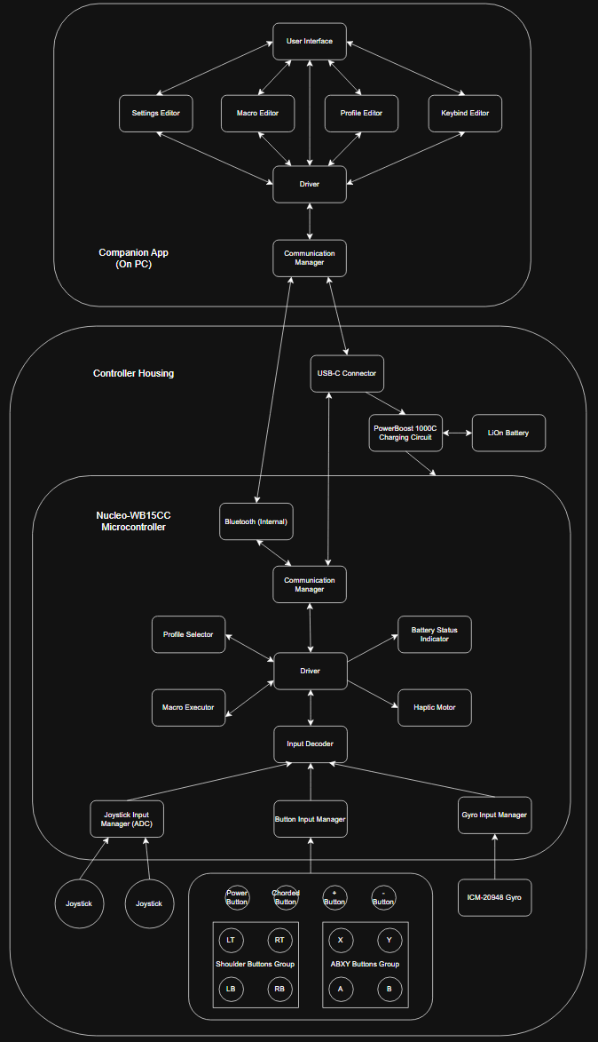
Top Level Block Diagram

Hardware Block Diagram
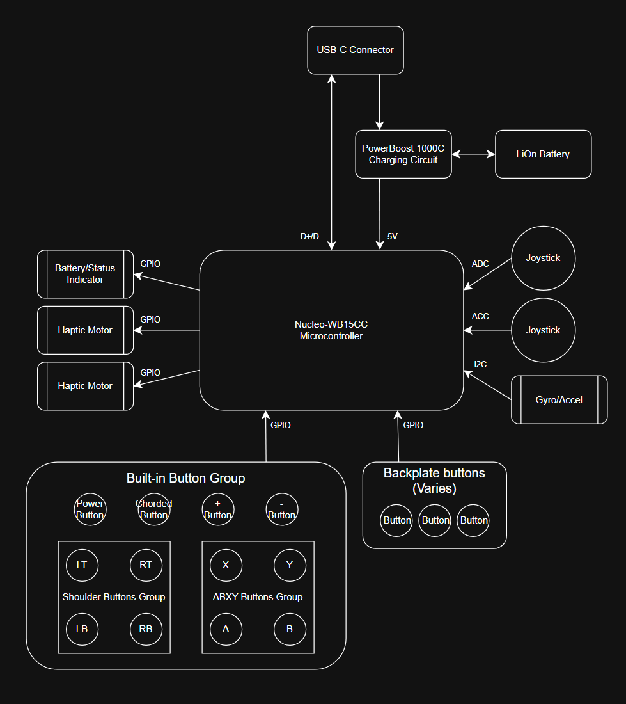
- ST Nucleo-WB15CC Datasheet & User Manuel
- USB-C Connector Reference Design
- Adafruit PowerBoost 1000C Documentation
- Analog Joystick Breakout Board Datasheet
- ICM-20948 IMU Datasheet

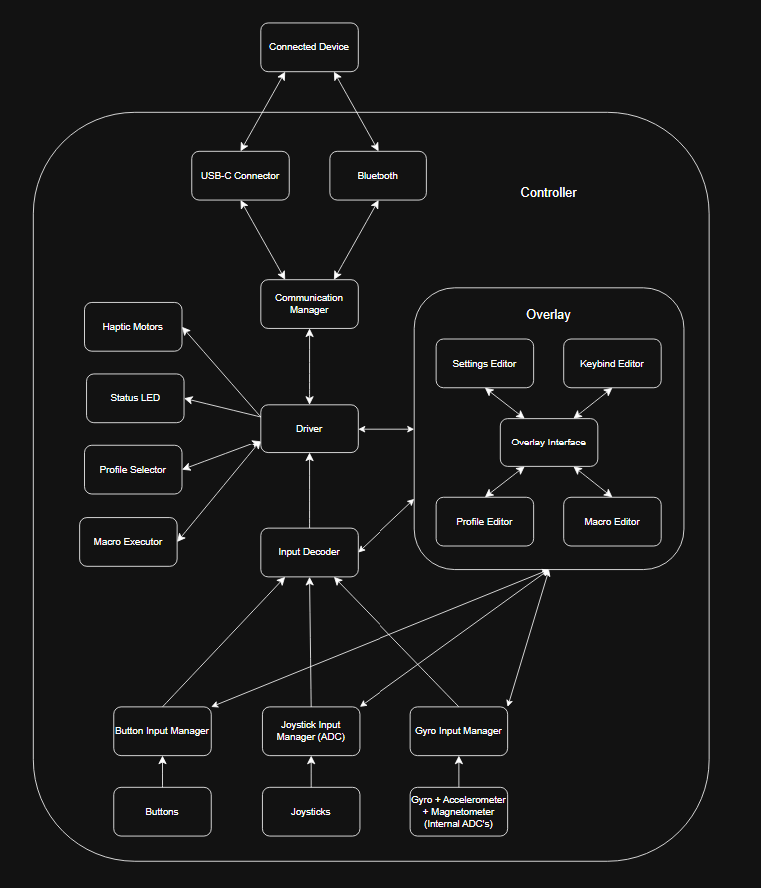
Software Block Diagram

- IDE: STM32CubeIDE
- Debugger: ST-Link
- Version Control: Gitlab
- OS: bare-metal
- ST Nucleo-WB15CC Datasheet & User Manuel
- STM32CubeWB HAL and LL API Reference Manuel
- STM32WB BLE Stack documentation
- ICM-20948 Register Map and Driver Documentation
- SQLite
Functional Block Diagram
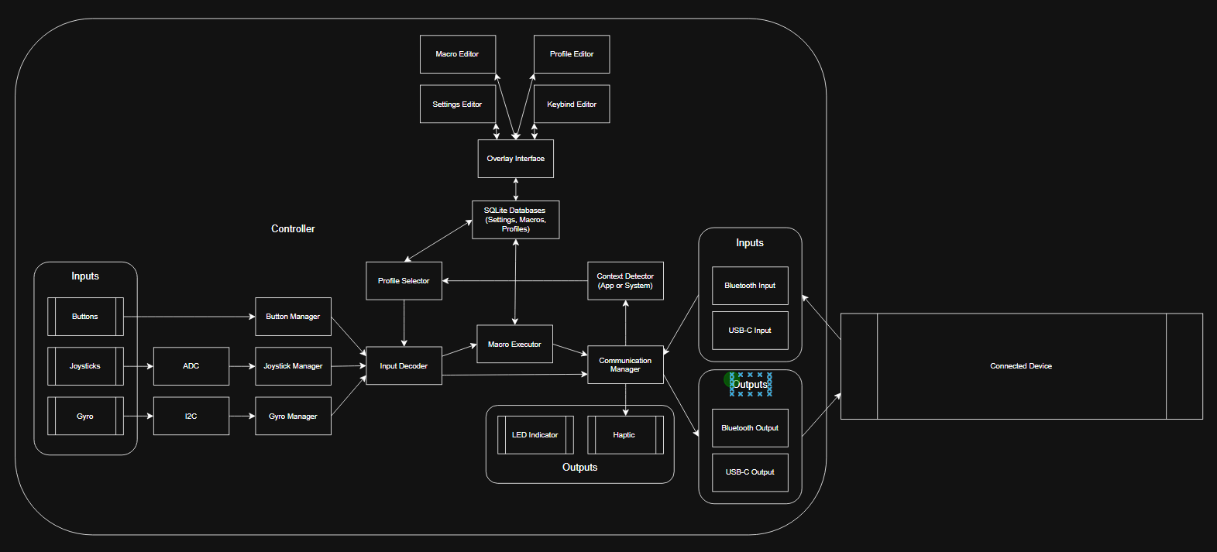

Cost Estimation

Components Cost
Component | Model | Unit Cost | Count | Quantity | Subtotal (per Unit)
Microcontroller | Nucleo-WB15CC | $35.60 | 1 | 1 | $35.60
USB-C Breakout | USB Type C Breakout Board | $2.95 | 1 | 1 | $2.95
Charging Circuit | Power Boost 1000C | $19.95 | 1 | 1 | $19.95
Battery | Lithium-ion battery | $7.95 | 1 | 1 | $7.95
Joysticks | Analog 2-axis thumb joystick | $5.95 | 1 | 2 | $11.90
LED | Rectangular 5mm RGB LEDs | $5.95 | 10 | 1 | $0.59
Buttons | Pushbutton Switch 12mm | $0.75 | 1 | 14 | $10.50
Haptic Motor | Flat coin button type vibrating motor | $9.99 | 6 | 1 | $1.67
Strap | Elastic Strap | $9.99 | 1 | 1 | $9.99
Wire | AWG Wire Solid Core Hookup Wire | $15.49 | 6 | 1 | $2.58
Gyroscope | ICM-20948 | $14.95 | 1 | 1 | $14.95
Misc group (wires, screws) |  | $10 |  | 1 | $10
3d Print Material Cost |  | $15 |  | 1 | $15
 |  |  |  | Total per Unit | $143.63

Production Cost
Category | Description | Estimated Cost | Units | Subtotal
Injection molds | 12 Printed Parts x $3000 | $36000.00 | 1000 | $36
Assembly labor | $13/hour x 2hour | $26 |  | $26
 |  |  | Total per Unit | $62

NRE Costs
 | Description | Rate | Subtotal
Firmware development | 1 Engineer X 100hrs | 25$/hr | 2500$
App developement | 1 Engineer X 100hrs | 25$/hr | 2500$
Debugging & Testing | 1 Engineer X 100hrs | 25$/hr | 2500$
Design Revisions | 1 Engineer X 50hrs | 25$/hr | 1250$
3d modelling | 1 Engineer X 75hrs | 25$/hr | 1875$
 |  | Total | 10625$
 |  | Total/Expected Units | $10.63

Operational Cost
Cost Type | Description | Subtotal
Staff Labor (Engineering, Marketing, Support) | 3 Staff x $5000/mo / 1000 | $15
Sales, Logistics, Website upkeep |  | $30
Marketing & Admin Costs |  | $30
 | Total per Unit | $75

Total Cost
Category | Costs
Component Cost / Unit | $143.63 per Unit
Production Cost / Unit | $62
NRE Cost per Unit | $10.63
Operational Cost | $75
Total cost per unit | $291.26

Chapter 4: Testing & Evaluation

Chapter 5: Conclusion & Future Work

Timeline

Fall Term Timeline
The overall timeline of this project will be to complete it before Idea fest in June 2026. Fall term will be the time to design the project, including specific technology, and initial modelling of the controller for 3d printing. Technologies chosen will have to be carefully planned in order to fit a chosen form factor and have enough stats to run smoothly. After initial planning, parts should be ordered, measured, and tested by the beginning of winter term.
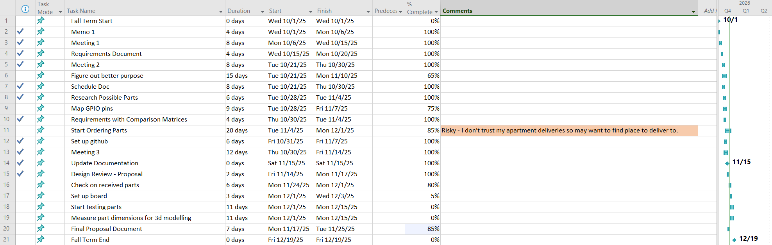

Winter Term Timeline
Winter term will be spent building, assembling, modelling, and coding. The goal of the term will be to have a working prototype by the end of it. The first few weeks will be primarily spent building the controller and writing the foundational code for the software. Starting with the controller’s driver code and inputs and then moving on to the app and compatibility with a variety of systems. The end of the term will be spent tying everything together and debugging in order to have a working prototype before spring term.
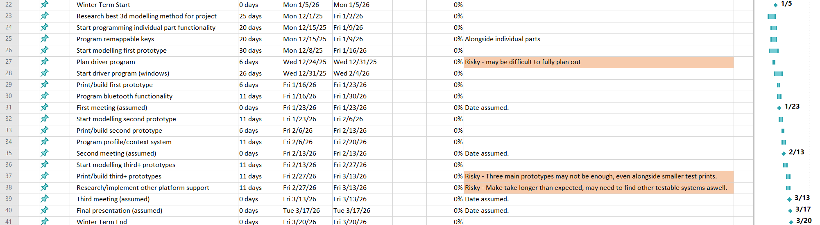

Spring Term Timeline
Finally, spring term will be spent testing, debugging and documenting. More rigorous testing will be used to help complete the prototype and bring it closer to 100% completion. The final product should be completed by idea fest as it will be presented to the public. Documentation should take place throughout the entire year, but the end of the term will be spent writing the user manual as well as the project documentation to completion.
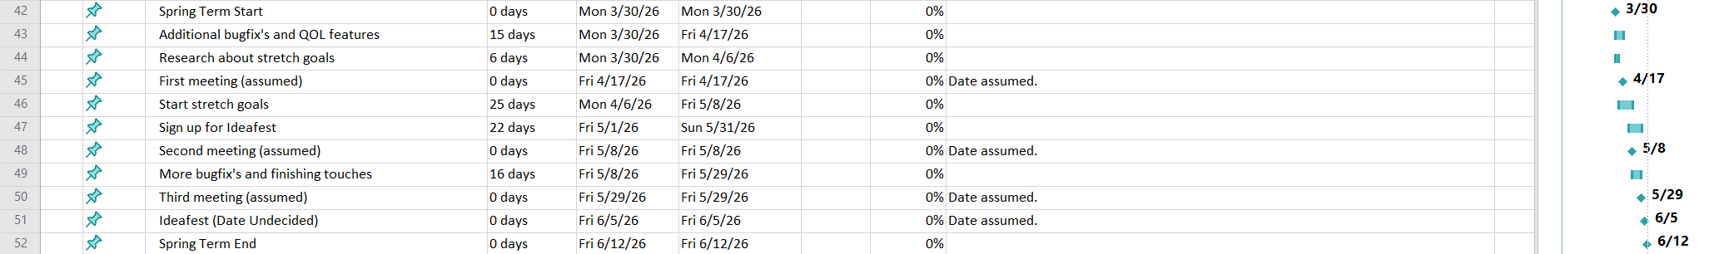

References
[1] STMicroelectronics, “NUCLEO WB15CC: STM32 Nucleo 64 development board.” [Online]. Available: https://www.st.com/en/evaluation-tools/nucleo-wb15cc.html
[2] Azeron, “Azeron – Game controllers for PC and consoles.” [Online]. Available: https://www.azeron.eu/
[3] Microsoft, “Xbox Adaptive Controller.” [Online]. Available: https://www.xbox.com/en-US/accessories/controllers/xbox-adaptive-controller
[4] A. Kuumeri, “One-handed DualShock 4,” Printables, Jan. 30, 2022. [Online]. Available: https://www.printables.com/model/126646-one-handed-dualshock-4printables.com+5reddit.com+5reddit.com+5
[5] B. J. Heckendorn, “Single-handed Xbox One controllers,” Benheck.com. Accessed: Jun. 11, 2025. [Online]. Available: https://www.benheck.com/controllers/
[6] OneSwitch.org.uk, “One handed game controllers.” Accessed: Jun. 11, 2025. [Online]. Available: https://oneswitch.org.uk/page/one-handed
[7] J. Walker, “ASCII Grip One-Handed RPG Controller Review (PlayStation),” 1 More Castle, May 1, 2014. [Online]. Available: https://www.1morecastle.com/2014/05/ascii-grip-one-handed-rpg-controller-review-playstation/
[8] Valve, “Valve Index Controllers,” Steam. Accessed: Jun. 11, 2025. [Online]. Available: https://store.steampowered.com/app/1059550/Valve_Index_Controllers/
[9] Tek Gear, “Twiddler 3 one-handed wearable keyboard & mouse.” [Online]. Available: https://www.mytwiddler.com/
[10] Akaki Controllers, “Akaki Controllers.” Accessed: Jun. 12, 2025. [Online]. Available: https://akaki.co/
[11] Evil Controllers, “Accessible controllers.” Accessed: Jun. 12, 2025. [Online]. Available: https://www.evilcontrollers.com/store/accessible-controllers
[12] Intel, “How to fix input lag.” [Online]. Available: https://www.intel.com/content/www/us/en/gaming/resources/how-to-fix-input-lag.html
[13] Ableton, “Bluetooth headphones and latency in Note.” [Online]. Available: https://help.ableton.com/hc/en-us/articles/6130134332188-Bluetooth-Headphones-and-Latency-in-Note

Appendix

Appendix A: Bill of Materials

